**BUSES**

1. HimSuta: (volvo and scania buses)

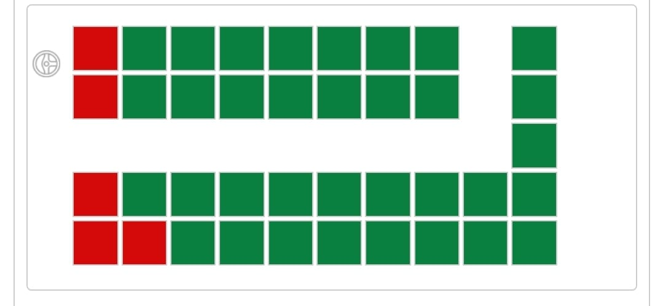

* 39 seats

1. HimMani: (Ashok Leyland Delux NON-AC buses)

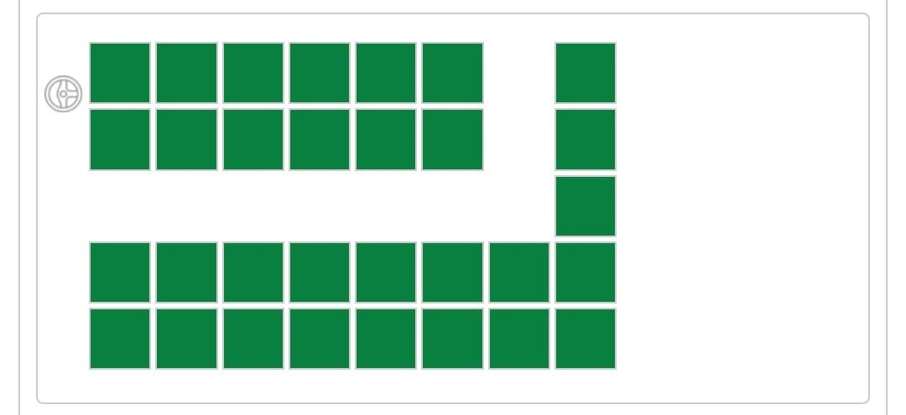

* 31 seats

1. HimTarang: (Electric Buses)

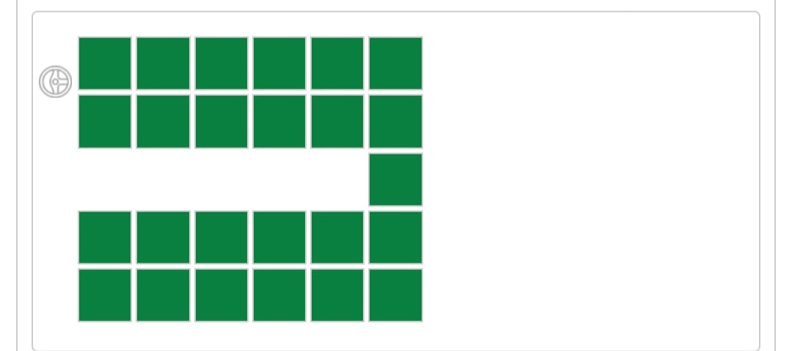

* 25 seats

1. HimDhara: (AC-Ordinary 3x2)

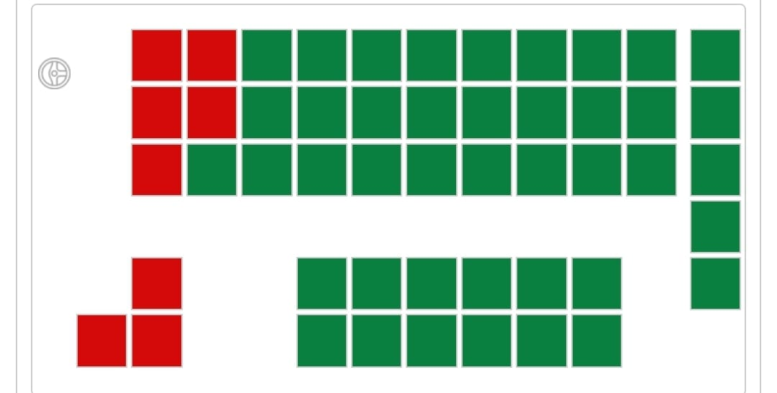

* 50 seats

1. Ordinary: (local city buses)

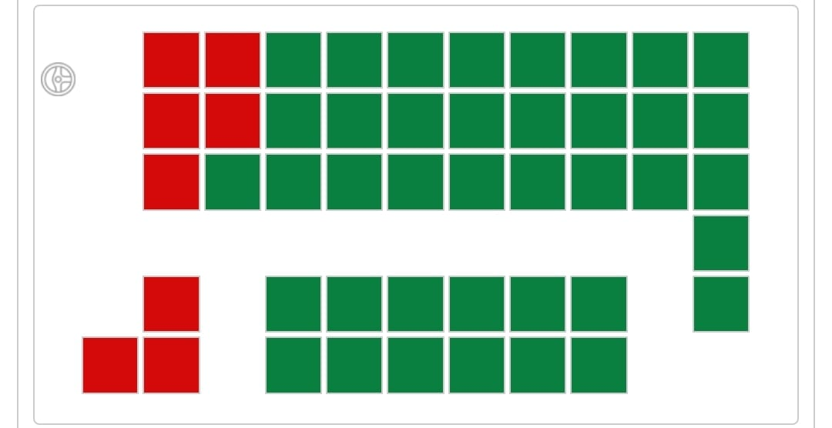

* 47 seats